Kubeadm installation on Ubuntu server

Step 1: System Networking & Kernel Prerequisites Execute these configurations to provision mandatory network forwarding rules and persistently disable system swap domains required by the Kubernetes scheduler architectures
# Permanently disable swap allocation
sudo swapoff -a
sudo sed -i '/ swap / s/^(.*)$/#\1/g' /etc/fstab
# Enable overlay and bridge network filtering modules
cat <<EOF | sudo tee /etc/modules-load.d/k8s.conf
overlay
br_netfilter
EOF
sudo modprobe overlay
sudo modprobe br_netfilter
# Configure sysctl networking rules dynamically
cat <<EOF | sudo tee /etc/sysctl.d/k8s.conf
net.bridge.bridge-nf-call-iptables = 1
net.bridge.bridge-nf-call-ip6tables = 1
net.ipv4.ip_forward = 1
EOF
sudo sysctl –system

To install kubeadm, kubectl, and kubelet on a Linux system, you need to add the official Kubernetes repository and install the packages.
Here are the complete steps for Ubuntu / Debian-based systems:
1. Update the system and install dependencies
bash
sudo apt-get update
sudo apt-get install -y apt-transport-https ca-certificates curl gpg

2. Download the public signing key
sudo mkdir -p -m 755 /etc/apt/keyrings
root@kubernetes:/etc/apt/sources.list.d# ls /etc/apt/keyrings/
cri-o-apt-keyring.gpg kubernetes-apt-keyring.gpg
root@kubernetes:/etc/apt/sources.list.d# ls
cri-o.list kubernetes.list ubuntu.sources ubuntu.sources.curtin.orig
root@kubernetes:/etc/apt/sources.list.d# cat cri-o.list
#deb [signed-by=/etc/apt/keyrings/cri-o-apt-keyring.gpg] https://download.opensuse.org/repositories/isv:/cri-o:/stable://deb/ /
root@kubernetes:/etc/apt/sources.list.d# cat kubernetes.list
deb [signed-by=/etc/apt/keyrings/kubernetes-apt-keyring.gpg] https://pkgs.k8s.io/core:/stable:/v1.33/deb/ /
root@kubernetes:/etc/apt/sources.list.d#
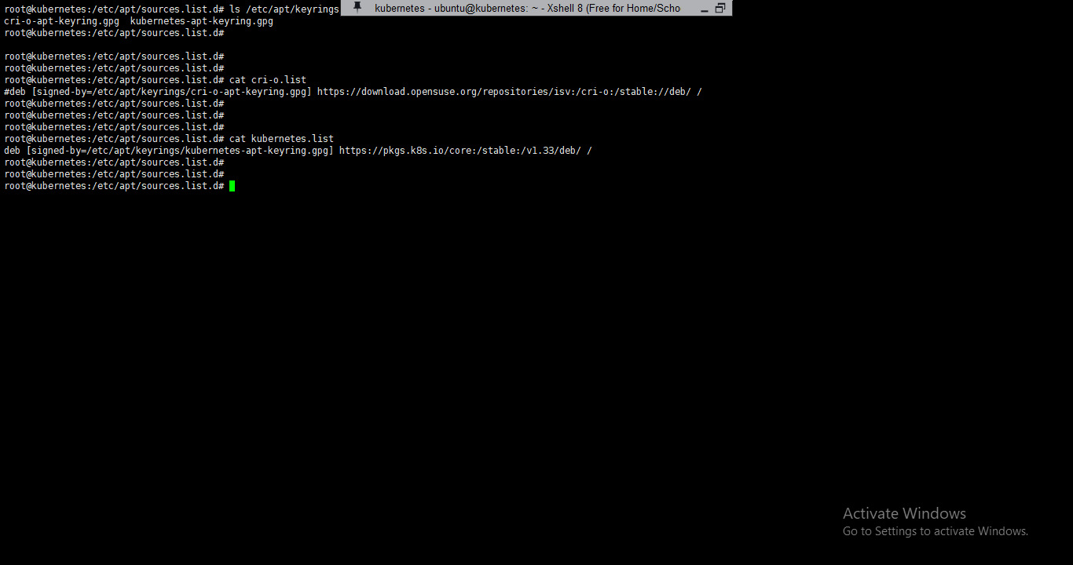

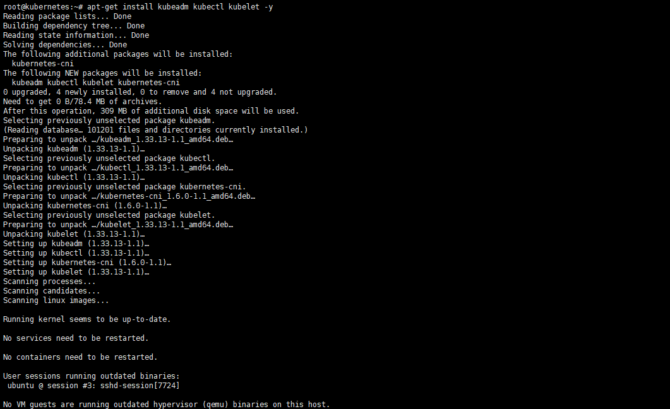
Step 2: Install and Configure CRI-O Runtime
Inject appropriate environment tracking parameters to match your targeted node installation footprint, synchronize standard modern repository sources, and configure basic operational runtime binaries
# Assign tracking parameters for stable runtime distributions
KUBERNETES_VERSION=v1.33
CRIO_VERSION=v1.33
# Append corresponding public signing certificates and source URLs
curl -fsSL https://pkgs.k8s.io/addons:/cri-o:/stable:/$CRIO_VERSION/deb/Release.key |sudo gpg --dearmor -o /etc/apt/keyrings/cri-o-apt-keyring.gpg https://pkgs.k8s.io/addons:/cri-o:/stable:/$CRIO_VERSION/deb/ /" | sudo tee /etc/apt/sources.list.d/cri-o.list
echo "deb [signed-by=/etc/apt/keyrings/cri-o-apt-keyring.gpg] https://download.opensuse.org/repositories/isv:/cri-o:/stable:/$CRIO_VERSION/deb/ /" | tee /etc/apt/sources.list.d/cri-o.list
# Perform targeted apt installation workflow steps
sudo apt-get update
sudo apt-get install -y cri-o
# Start and register daemon parameters systematically
sudo systemctl daemon-reload
sudo systemctl enable cri-o --now

echo "deb [signed-by=/etc/apt/keyrings/cri-o-apt-keyring.gpg] https://download.opensuse.org/repositories/isv:/cri-o:/stable:/$CRIO_VERSION/deb/ /" | tee /etc/apt/sources.list.d/cri-o.list
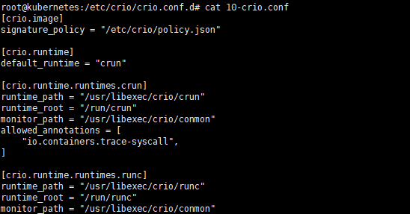

root@kubernetes:~#
sudo kubeadm init --pod-network-cidr=10.244.0.0/16 --cri-socket=unix:///var/run/crio/crio.sock --apiserver-advertise-address=192.168.0.11
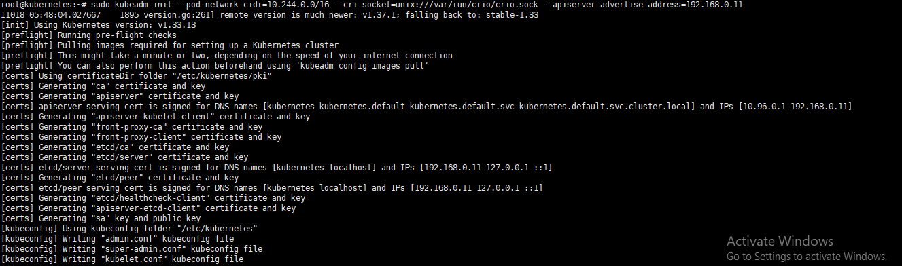
I1018 05:48:04.027667 1895 version.go:261] remote version is much newer: v1.37.1; falling back to: stable-1.33
[init] Using Kubernetes version: v1.33.13
[preflight] Running pre-flight checks
[preflight] Pulling images required for setting up a Kubernetes cluster
[preflight] This might take a minute or two, depending on the speed of your internet connection
[preflight] You can also perform this action beforehand using 'kubeadm config images pull'
[certs] Using certificateDir folder "/etc/kubernetes/pki"
[certs] Generating "ca" certificate and key
[certs] Generating "apiserver" certificate and key
[certs] apiserver serving cert is signed for DNS names [kubernetes kubernetes.default kubernetes.default.svc kubernetes.default.svc.cluster.local] and IPs [10.96.0.1 192.168.0.11]
[certs] Generating "apiserver-kubelet-client" certificate and key
[certs] Generating "front-proxy-ca" certificate and key
[certs] Generating "front-proxy-client" certificate and key
[certs] Generating "etcd/ca" certificate and key
[certs] Generating "etcd/server" certificate and key
[certs] etcd/server serving cert is signed for DNS names [kubernetes localhost] and IPs [192.168.0.11 127.0.0.1 ::1]
[certs] Generating "etcd/peer" certificate and key
[certs] etcd/peer serving cert is signed for DNS names [kubernetes localhost] and IPs [192.168.0.11 127.0.0.1 ::1]
[certs] Generating "etcd/healthcheck-client" certificate and key
[certs] Generating "apiserver-etcd-client" certificate and key
[certs] Generating "sa" key and public key
[kubeconfig] Using kubeconfig folder "/etc/kubernetes"
[kubeconfig] Writing "admin.conf" kubeconfig file
[kubeconfig] Writing "super-admin.conf" kubeconfig file
[kubeconfig] Writing "kubelet.conf" kubeconfig file
[kubeconfig] Writing "controller-manager.conf" kubeconfig file
[kubeconfig] Writing "scheduler.conf" kubeconfig file
[etcd] Creating static Pod manifest for local etcd in "/etc/kubernetes/manifests"
[control-plane] Using manifest folder "/etc/kubernetes/manifests"
[control-plane] Creating static Pod manifest for "kube-apiserver"
[control-plane] Creating static Pod manifest for "kube-controller-manager"
[control-plane] Creating static Pod manifest for "kube-scheduler"
[kubelet-start] Writing kubelet environment file with flags to file "/var/lib/kubelet/kubeadm-flags.env"
[kubelet-start] Writing kubelet configuration to file "/var/lib/kubelet/config.yaml"
[kubelet-start] Starting the kubelet
[wait-control-plane] Waiting for the kubelet to boot up the control plane as static Pods from directory "/etc/kubernetes/manifests"
[kubelet-check] Waiting for a healthy kubelet at http://127.0.0.1:10248/healthz. This can take up to 4m0s
[kubelet-check] The kubelet is healthy after 27.36576ms
[control-plane-check] Waiting for healthy control plane components. This can take up to 4m0s
[control-plane-check] Checking kube-apiserver at https://192.168.0.11:6443/livez
[control-plane-check] Checking kube-controller-manager at https://127.0.0.1:10257/healthz
[control-plane-check] Checking kube-scheduler at https://127.0.0.1:10259/livez
[control-plane-check] kube-controller-manager is healthy after 49.985946ms
[control-plane-check] kube-scheduler is healthy after 121.123959ms
[control-plane-check] kube-apiserver is healthy after 6.50570905s
[upload-config] Storing the configuration used in ConfigMap "kubeadm-config" in the "kube-system" Namespace
[kubelet] Creating a ConfigMap "kubelet-config" in namespace kube-system with the configuration for the kubelets in the cluster
[upload-certs] Skipping phase. Please see --upload-certs
[mark-control-plane] Marking the node kubernetes as control-plane by adding the labels: [node-role.kubernetes.io/control-plane node.kubernetes.io/exclude-from-external-load-balancers]
[mark-control-plane] Marking the node kubernetes as control-plane by adding the taints [node-role.kubernetes.io/control-plane:NoSchedule]
[bootstrap-token] Using token: fm5zo3.iup63bcjfve7m7mz
[bootstrap-token] Configuring bootstrap tokens, cluster-info ConfigMap, RBAC Roles
[bootstrap-token] Configured RBAC rules to allow Node Bootstrap tokens to get nodes
[bootstrap-token] Configured RBAC rules to allow Node Bootstrap tokens to post CSRs in order for nodes to get long term certificate credentials
[bootstrap-token] Configured RBAC rules to allow the csrapprover controller automatically approve CSRs from a Node Bootstrap Token
[bootstrap-token] Configured RBAC rules to allow certificate rotation for all node client certificates in the cluster
[bootstrap-token] Configured RBAC rules to allow the API server kubelet client certificate to access the kubelet API
[bootstrap-token] Creating the "cluster-info" ConfigMap in the "kube-public" namespace
[kubelet-finalize] Updating "/etc/kubernetes/kubelet.conf" to point to a rotatable kubelet client certificate and key
[addons] Applied essential addon: CoreDNS
[addons] Applied essential addon: kube-proxy

Your Kubernetes control-plane has initialized successfully!

To start using your cluster, you need to run the following as a regular user:

mkdir -p $HOME/.kube
sudo cp -i /etc/kubernetes/admin.conf $HOME/.kube/config
sudo chown $(id -u):$(id -g) $HOME/.kube/config

Alternatively, if you are the root user, you can run:

export KUBECONFIG=/etc/kubernetes/admin.conf

You should now deploy a pod network to the cluster.
Run "kubectl apply -f [podnetwork].yaml" with one of the options listed at:
https://kubernetes.io/docs/concepts/cluster-administration/addons/

Then you can join any number of worker nodes by running the following on each as root:

kubeadm join 192.168.0.11:6443 --token fm5zo3.iup63bcjfve7m7mz \
--discovery-token-ca-cert-hash sha256:7dcd17b02e43866b041a24be8a4f81f35387e46103b6affc74ace9a62cc3b2e3
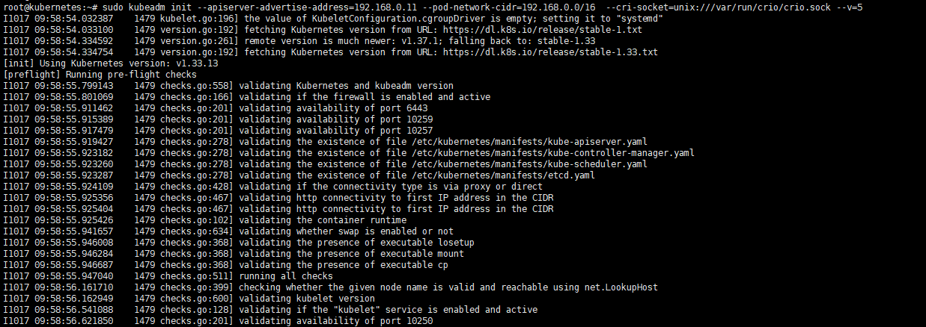

Your Kubernetes control-plane has initialized successfully!

To start using your cluster, you need to run the following as a regular user:

mkdir -p $HOME/.kube
sudo cp -i /etc/kubernetes/admin.conf $HOME/.kube/config
sudo chown $(id -u):$(id -g) $HOME/.kube/config

Alternatively, if you are the root user, you can run:

export KUBECONFIG=/etc/kubernetes/admin.conf

You should now deploy a pod network to the cluster.
Run "kubectl apply -f [podnetwork].yaml" with one of the options listed at:
https://kubernetes.io/docs/concepts/cluster-administration/addons/

Then you can join any number of worker nodes by running the following on each as root:

kubeadm join 192.168.0.11:6443 --token fm5zo3.iup63bcjfve7m7mz \
--discovery-token-ca-cert-hash sha256:7dcd17b02e43866b041a24be8a4f81f35387e46103b6affc74ace9a62cc3b2e3
Deploy the Flannel CNI Plugin
root@kubernetes:~#
kubectl apply -f https://github.com/flannel-io/flannel/releases/latest/download/kube-flannel.yml
namespace/kube-flannel created
flannel created
clusterrole.rbac.authorization.k8s.io/flannel created
clusterrolebinding.rbac.authorization.k8s.io/flannel created
configmap/kube-flannel-cfg created
daemonset.apps/kube-flannel-ds created
Verify Node and Network Status
kubectl get nodes
Check Flannel Pods: Ensure all system components and the kube-flannel daemonset pods are in the Running state
kubectl get pods -n kube-flannel

ON Slave node

Follow the steps upto kubeadm package installations
Copy the crio file or write the same crio config file as master node
root@slave-1:/etc/crio/crio.conf.d# cat 10-crio.conf
[crio.image]
signature_policy = "/etc/crio/policy.json"

[crio.runtime]
default_runtime = "crun"

[crio.runtime.runtimes.crun]
runtime_path = "/usr/libexec/crio/crun"
runtime_root = "/run/crun"
monitor_path = "/usr/libexec/crio/conmon"
allowed_annotations = ["io.containers.trace-syscall",]

[crio.runtime.runtimes.runc]
runtime_path = "/usr/libexec/crio/runc"
runtime_root = "/run/runc"
monitor_path = "/usr/libexec/crio/conmon"
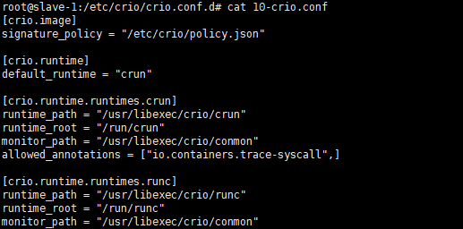
root@slave-1:/etc/crio/crio.conf.d# kubeadm join 192.168.0.11:6443 --token veda5y.kf59fd7zmbkdjndw --discovery-token-ca-cert-hash sha256:7dcd17b02e43866b041a24be8a4f81f35387e46103b6affc74ace9a62cc3b2e3 --v=5
I1018 07:49:27.213417 6996 join.go:423] [preflight] found NodeName empty; using OS hostname as NodeName
I1018 07:49:27.217448 6996 initconfiguration.go:125] detected and using CRI socket: unix:///var/run/crio/crio.sock
[preflight] Running pre-flight checks
I1018 07:49:27.234931 6996 preflight.go:93] [preflight] Running general checks
I1018 07:49:27.340505 6996 checks.go:278] validating the existence of file /etc/kubernetes/kubelet.conf
I1018 07:49:27.344090 6996 checks.go:278] validating the existence of file /etc/kubernetes/bootstrap-kubelet.conf
I1018 07:49:27.344152 6996 checks.go:102] validating the container runtime
I1018 07:49:27.372953 6996 checks.go:634] validating whether swap is enabled or not
I1018 07:49:27.373133 6996 checks.go:368] validating the presence of executable losetup
I1018 07:49:27.373204 6996 checks.go:368] validating the presence of executable mount
I1018 07:49:27.373265 6996 checks.go:368] validating the presence of executable cp
I1018 07:49:27.373318 6996 checks.go:511] running all checks
I1018 07:49:27.764200 6996 checks.go:399] checking whether the given node name is valid and reachable using net.LookupHost
I1018 07:49:27.764623 6996 checks.go:600] validating kubelet version
I1018 07:49:30.268833 6996 checks.go:128] validating if the "kubelet" service is enabled and active
I1018 07:49:30.493336 6996 checks.go:201] validating availability of port 10250
I1018 07:49:30.519884 6996 checks.go:278] validating the existence of file /etc/kubernetes/pki/ca.crt
I1018 07:49:30.525600 6996 checks.go:428] validating if the connectivity type is via proxy or direct
I1018 07:49:30.526604 6996 checks.go:327] validating the contents of file /proc/sys/net/ipv4/ip_forward
I1018 07:49:30.532925 6996 join.go:553] [preflight] Discovering cluster-info
I1018 07:49:30.533116 6996 token.go:72] [discovery] Created cluster-info discovery client, requesting info from "192.168.0.11:6443"
I1018 07:49:30.567649 6996 envvar.go:172] "Feature gate default state" feature="InOrderInformers" enabled=true
I1018 07:49:30.567868 6996 envvar.go:172] "Feature gate default state" feature="WatchListClient" enabled=false
I1018 07:49:30.567997 6996 envvar.go:172] "Feature gate default state" feature="ClientsAllowCBOR" enabled=false
I1018 07:49:30.568137 6996 envvar.go:172] "Feature gate default state" feature="ClientsPreferCBOR" enabled=false
I1018 07:49:30.568267 6996 envvar.go:172] "Feature gate default state" feature="InformerResourceVersion" enabled=false
I1018 07:49:30.585804 6996 token.go:230] [discovery] Waiting for the cluster-info ConfigMap to receive a JWS signature for token ID "veda5y"
I1018 07:49:30.748122 6996 token.go:127] [discovery] Requesting info from "192.168.0.11:6443" again to validate TLS against the pinned public key
I1018 07:49:30.753095 6996 token.go:230] [discovery] Waiting for the cluster-info ConfigMap to receive a JWS signature for token ID "veda5y"
I1018 07:49:30.890856 6996 token.go:150] [discovery] Cluster info signature and contents are valid and TLS certificate validates against pinned roots, will use API Server "192.168.0.11:6443"
I1018 07:49:30.891094 6996 discovery.go:54] [discovery] Using provided TLSBootstrapToken as authentication credentials for the join process
I1018 07:49:30.891142 6996 join.go:567] [preflight] Fetching init configuration
I1018 07:49:30.891159 6996 join.go:681] [preflight] Retrieving KubeConfig objects
[preflight] Reading configuration from the "kubeadm-config" ConfigMap in namespace "kube-system"...
[preflight] Use 'kubeadm init phase upload-config --config your-config-file' to re-upload it.
I1018 07:49:31.089172 6996 kubeproxy.go:55] attempting to download the KubeProxyConfiguration from ConfigMap "kube-proxy"
I1018 07:49:31.169003 6996 kubelet.go:74] attempting to download the KubeletConfiguration from ConfigMap "kubelet-config"
I1018 07:49:31.310879 6996 initconfiguration.go:117] skip CRI socket detection, fill with the default CRI socket unix:///var/run/containerd/containerd.sock
W1018 07:49:31.325284 6996 utils.go:69] The recommended value for "bindAddress" in "KubeProxyConfiguration" is: ::; the provided value is: 0.0.0.0
I1018 07:49:31.325439 6996 preflight.go:108] [preflight] Running configuration dependant checks
I1018 07:49:31.325481 6996 controlplaneprepare.go:225] [download-certs] Skipping certs download
I1018 07:49:31.335971 6996 kubelet.go:167] [kubelet-start] writing bootstrap kubelet config file at /etc/kubernetes/bootstrap-kubelet.conf
I1018 07:49:31.375037 6996 kubelet.go:182] [kubelet-start] writing CA certificate at /etc/kubernetes/pki/ca.crt
I1018 07:49:31.384326 6996 kubelet.go:198] [kubelet-start] Checking for an existing Node in the cluster with name "slave-1" and status "Ready"
I1018 07:49:31.473749 6996 kubelet.go:213] [kubelet-start] Stopping the kubelet
[kubelet-start] Writing kubelet configuration to file "/var/lib/kubelet/config.yaml"
[kubelet-start] Writing kubelet environment file with flags to file "/var/lib/kubelet/kubeadm-flags.env"
[kubelet-start] Starting the kubelet
[kubelet-check] Waiting for a healthy kubelet at http://127.0.0.1:10248/healthz. This can take up to 4m0s
[kubelet-check] The kubelet is healthy after 1.617992525s
[kubelet-start] Waiting for the kubelet to perform the TLS Bootstrap
I1018 07:49:38.375020 6996 cert_rotation.go:141] "Starting client certificate rotation controller" logger="tls-transport-cache"
I1018 07:49:38.415751 6996 kubelet.go:332] [kubelet-start] preserving the crisocket information for the node
I1018 07:49:38.415829 6996 patchnode.go:32] [patchnode] Uploading the CRI socket "unix:///var/run/crio/crio.sock" to Node "slave-1" as an annotation

This node has joined the cluster:
* Certificate signing request was sent to apiserver and a response was received.
* The Kubelet was informed of the new secure connection details.
Add /etc/hosts
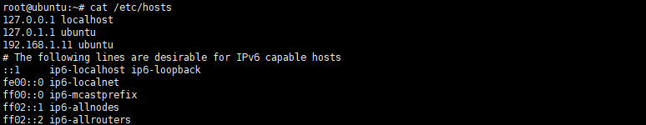

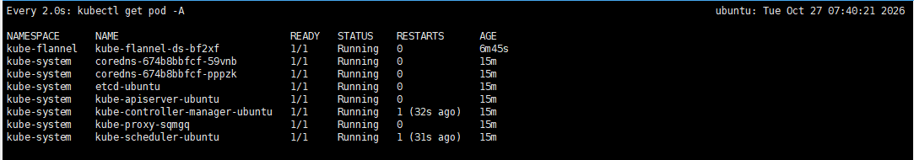
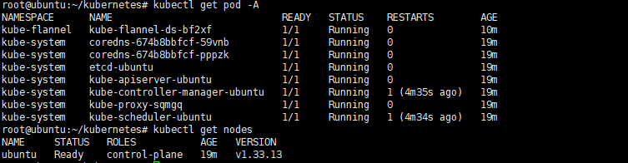
Run 'kubectl get nodes' on the control-plane to see this node join the cluster.
root@kubernetes:/# kubectl get nodes -o wide
NAME STATUS ROLES AGE VERSION INTERNAL-IP EXTERNAL-IP OS-IMAGE KERNEL-VERSION CONTAINER-RUNTIME
kubernetes Ready control-plane 142m v1.33.13 192.168.0.11 <none> Ubuntu 26.10 7.3.0-9-generic cri-o://1.33.13
slave-1 NotReady <none> 20m v1.33.13 192.168.0.15 <none> Ubuntu 26.10 7.3.0-9-generic cri-o://1.33.13

If coredns is in pending
Do host entry

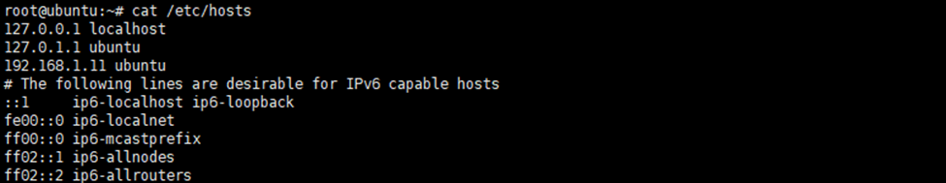

Common Causes and Fixes
- Missing CNI Plugin CoreDNS requires a Container Networking Interface (CNI) plugin for networking. If no CNI is installed, the pods will remain pending.
kubectl apply -f https://docs.projectcalico.org/manifests/calico.yaml

- Node Not Ready If nodes are unschedulable or not ready, CoreDNS cannot start.
kubectl get nodes

- Insufficient Resources CoreDNS may fail to schedule if there are insufficient CPU or memory resources.
kubectl describe pod coredns-<pod-name> -n kube-system

- PersistentVolumeClaim Issues If CoreDNS uses a PVC and it is unbound, fix the PVC binding.
kubectl get pvc -n kube-system

